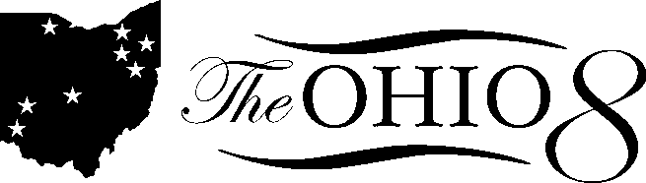

Assignment Areas for Ohio 8 Members

Charter Reform – Eric Gordon, Dan Good, Julie Sellers
CORAS – Lori Ward, Mary Ronan
State Board of Education – Lori Ward, Mary Ronan (Debe Terhar)
Colleen Grady (Ed. Policy advisor for the House) – Adrian Allison
Lehner & Stebelton – Tracy Johnson
Graduation Requirements – Dan Good, Geneva Parker, David Romick
Gifted – Colleen Boyle (Gifted Coordinator for Columbus)
Academics – Pat Shipe, David James, Connie Hathorn, Larry Ellis
Work Plan – David Quolke, David James
Juvenile Justice System – Mary Ronan, Eric Gordan, Romules Durant, David James, Kevin Dalton
Gun Law – Eric Gordon
Columbus – All
School Funding Caucus – Lori Ward (Lori Snyder Lowe)

