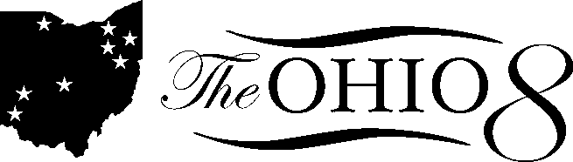

Straight A Fund Basics

Goals of the grant (application must address one of these goals):
- Raise student achievement
- Significant reduction in spending
- Target greater share of funding to the classroom

Statutes require application to include:
- Project description
- Self-sustaining
- Quantifiable results
- Sustainability after grant cycle, applies to all three goals of project

Awards:
- $150M for FY2015
- $5M for each applicant
- $15M for consortia

IMPORTANT:
The is focus on the following: Ambidextrous organizations - process improvement AND disruptive innovation

Expectations of fund:
- Changes in behavior (students, educators, families, policymakers, innovators, researchers)

Scoring process:
- Step 1: Sustainability review:
  - Is the project credible?
  - Does the project have sustainable costs?
  - Is the project sustainable?
- Step 2:Programatic review:
  - Project description
  - Implementation
  - Substantial impact and lasting value
  - Summary
- Must pass sustainability review before application will be passed on to programmatic review

Timelines/key dates – An email just came out on 3/17 with changes to the dates, as follows:
- 3/25: Webinar at 3:30pm to explain changes in detail.
- 4/4: Application opens in CCIP
- 4/18: Application deadline
- 5/12: Governing board meeting on fiscal sustainability results (approval 5/21)
- 6/16: Governing board meeting on programmatic results (approval 6/20)
- 7/28: Controlling board

